Chapter 3, Problem 54.

Find the mesh currents i₁, i₂, and i₃ in the circuit in Fig. 3.99.

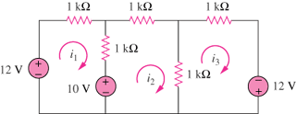

Figure 3.99
For Prob. 3.54

